Lab 2

Hector Ramirez & Duy Vu

Assignment 1

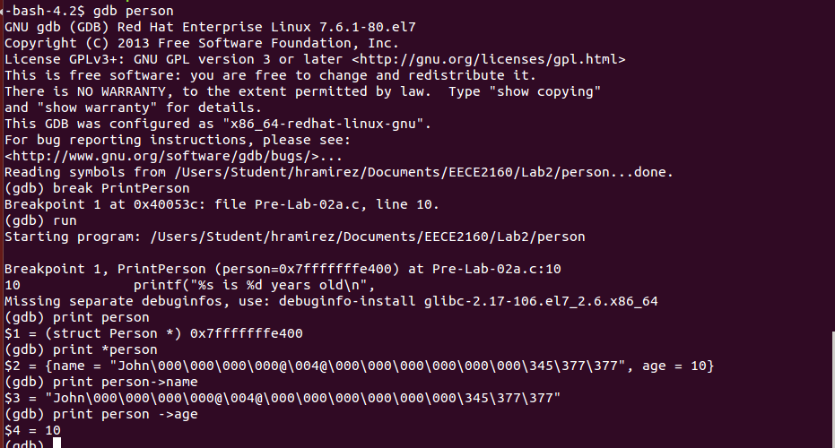
print person: will give the data type of person, and its adress

print *person: dereferences the person and provides you with all the members in it's memory allocation

print person->name: will provide you with the name member of this object

print person->age: will provide you witht the age member of this object

Assignment 2

Assignment 3
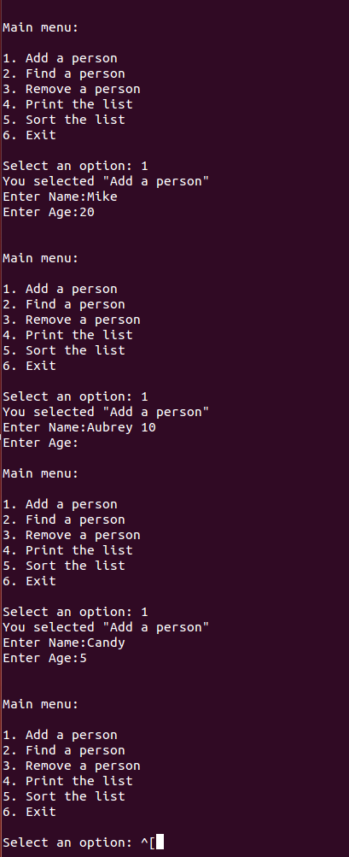
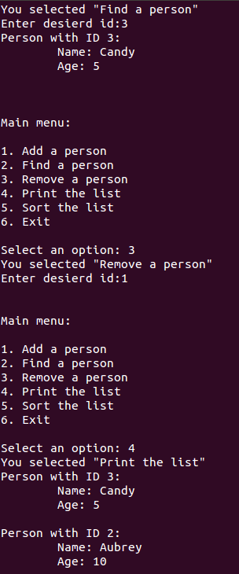

For Assignment 3, we believe we obtained the expected output for each of the different functions.

Assignment 4

Assignment 5

